Jake Hanson

**Manual Fan Controller**

Fan is controlled through two buttons, a slow and fast speed.

The fan and stepper motor simulate an air conditioning fan for a car or house cooling or heating system.

The buttons allow the user to manually select a fan speed. The fan has three speeds (Off, Slow, Fast), with LEDs letting the user know what speed is selected. Red is off, yellow is slow speed, and green is fast speed.

After touching one of the buttons, the mode selected LED powers on, along with the stepper motor which runs at the speed selected. After roughly 4 seconds, the motor turns off and the LED switches back to “off”, or red.

**Components:**

Switches

Stepper Motor + Controller Module (ULN2003)

Power board (9v extra power for stepper motor)

9V battery

LEDs (3)

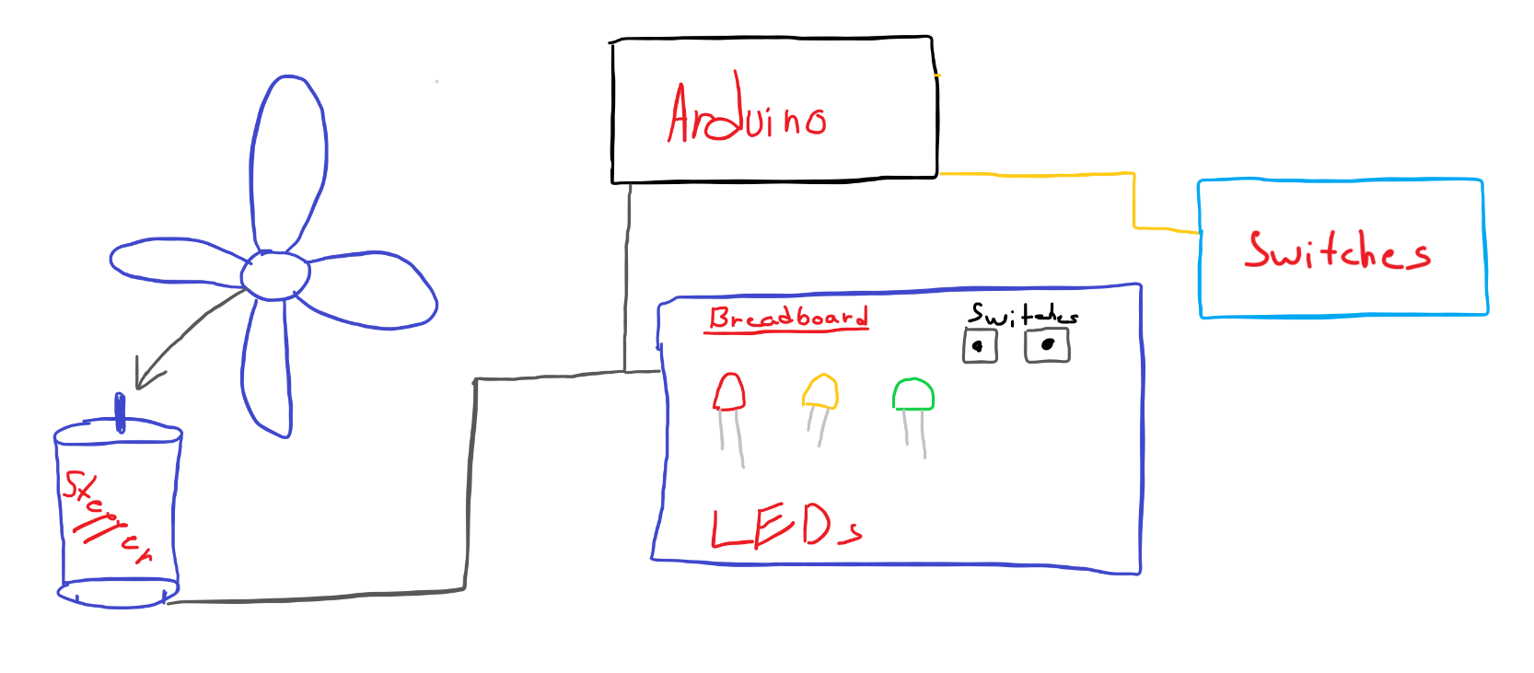

Previously, we planned on using the DC motor. After struggling with the DC motor control, we opted for the stepper motor. As such, the stepper motor would not be used in a real world example, but for the demonstration it works well.